**TEST TASK**

Design the test cases for next requirement. You don’t need to describe fully all TCs, just 1 or 2.

Also, describe briefly how you would test it (including tools, data dependency, etc). Make any assumption you need in order to complete the task and specify them in the solution.

Requirement

It is required to create a REST service that rates and bills customer calls.

Service input is:

* Customer unique code.
* Phone number.
* Call start date.
* Call stop date.

Customers are classified in two pricing structures:

* Regular: they are charged 1 EUR per minute. Minutes are rounded up (a call that lasted 61 seconds will be rounded to 2 minutes)
* VIP: they are charged 1 cent per second.

Customer information is persisted in DB. Table CUSTOMER_PSTRUCTURE structure is:

* CUSTOMER_CODE - VARCHAR2 (10).
* PRICING_STRUCTURE – VARCHAR2 (10). Domain values are (‘REG’, ‘VIP’)

**Solution:**

Let's assume we have CUSTOMERS table in our database with the following data:

|  |  |  |
| --- | --- | --- |
| CUSTOMER_UCODE | NAME | ... |
| 1234 | Test Customer 1 | ... |
| 1235 | Test Customer 2 | ... |
| ... | ... | ... |

Let's also assume that we have this data in our CUSTOMER_PSTRUCTURE table:

|  |  |
| --- | --- |
| CUSTOMER_UCODE | PRICING_STRUCTURE |
| 1234 | REG |
| 1235 | VIP |

We will have two test cases, with the following input data:

**TC1, input:**

**customerUcode: 1234**

**phone: 062123123**

**startDate: 2018-01-01T20:40:50**

**endDate: 2018-01-01T20:41:20**

**TC2, input:**

**customerUcode: 1235**

**phone: 062321321**

**startDate: 2018-01-01T20:20:00**

**endDate: 2018-01-01T20:22:15**

To calculate the expected results for TC1, first we will find out the pricing structure for this customer by executing query on our db:

*SELECT * from CUSTOMER_PSTRUCTURE where customer_ucode = 1234*

We will find out that it's pricing structure is REG, which means the phone call price for this customer is 1EUR per minute.

Then we will calculate the call duration by substracting startDate from endDate.

duration = endDate – startDate = 30 seconds

This will be rounded to 1 minute, so the calculation will be:

bill amount = duration * price = 1 * 1EUR = 1EUR

The expected bill amount for this customer is **1EUR.**

To calculate the expected results for TC2, first we will find out the pricing structure for this customer by executing query on our db:

*SELECT * from CUSTOMER_PSTRUCTURE where customer_ucode = 1235*

We will find out that it's pricing structure is VIP, which means the phone call price for this customer is 1 cent per second.

Then we will calculate the call duration by substracting startDate from endDate.

duration = endDate – startDate = 135 seconds

So the calculation would be:

bill amount = duration * price = 135 * 1 cent = 135 cents = 1.35 EUR

The expected bill amount for this customer is **1.35 EUR.**

In order to test REST API we will check it's documentation to find out information about request type, URL, header, parameters, and response body.

Let's assume that the request URL is

<http://enit.ba/rest/bill>

and the response will only contain bill amount in EUR.

We will use Postman tool for REST API testing. These test cases are shown in the following images:

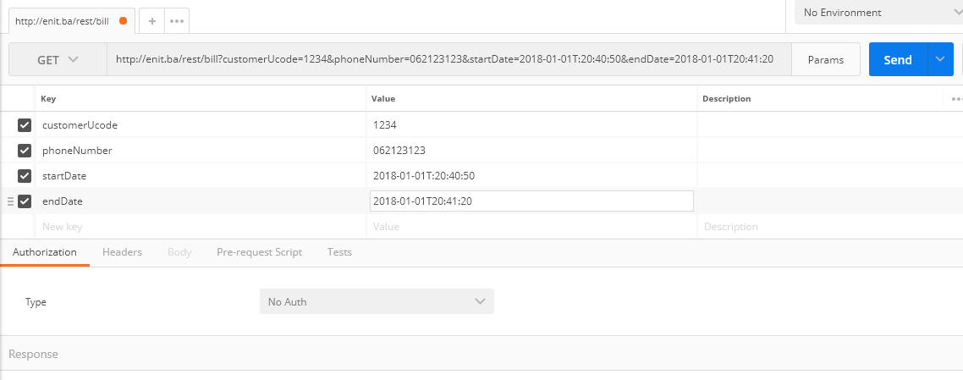

Let's assume the response body would look like this:

{

billAmount: 1

}

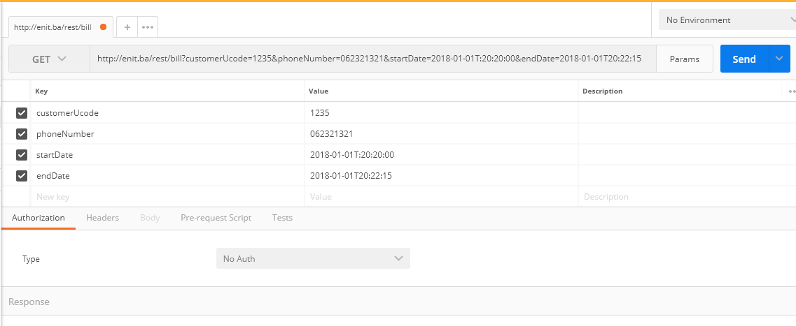

Let's assume the response body would look like this:

{

billAmount: 1.35

}

The test cases document will be provided in a separate Excell file.